Heat
Class test
FM – 10
- A beggar wrapped himself with a few layers of newspaper on a cold winter night. This helped him to keep himself warm because (1)
(a) friction between the layers of newspaper produces heat.
(b) air trapped between the layers of newspaper is a bad conductor of heat.
(c) newspaper is a conductor of heat.
(d) newspaper is at a higher temperature than the temperature of the surrounding.

2) Assertion (A) : A clinical thermometer has a scale in the range of 37°C to 45°C
Reason (R) : The normal temperature of human body is 37°C. (1)
- Assertion and reason both are correct statement and reason is correct explanation for assertion.
- Assertion and reason both are correct statement and reason is not correct explanation for assertion.
- Assertion is correct statement but reason is wrong statement.
- Assertion is wrong statement but reason is correct statement.

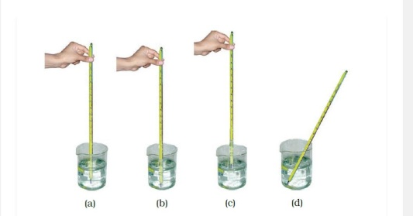
3) Four arrangements to measure the temperature of the ice in a beaker with laboratory thermometer are shown in Figure (a, b, c and d). Which one of them shows the correct arrangement for accurate measurement of temperature? Support your answer with reason.(2)

4) To keep her soup warm Paheli wrapped the container in which it was kept with a woollen cloth. Can she apply the same method to keep a glass of cold drink cool? Give a reason for your answer (1)
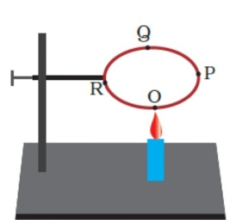
5) A circular metal loop is heated at point O as shown in Figure.
(i) In which direction would heat flow in the loop? (1)
(ii) In which order the pins at points P,Q and R fixed with the help of wax fall if points O, P, Q and R are equidistant from each other? (1)

6) Neha's parents are planning to construct a house in a coastal area, in which direction should the windows preferably face and why? (1)
7) Convert 50 °F into kelvin. (1)
8) The boiling point of water is 100°C. What is it’s value in kelvin. (1)

